1. **Setting Up Junit**

<project xmlns="http://maven.apache.org/POM/4.0.0"

xmlns:xsi="http://www.w3.org/2001/XMLSchema-instance"

xsi:schemaLocation="http://maven.apache.org/POM/4.0.0

https://maven.apache.org/xsd/maven-4.0.0.xsd">

<modelVersion>4.0.0</modelVersion>

<groupId>Number</groupId>

<artifactId>Test</artifactId>

<version>0.0.1-SNAPSHOT</version>

<dependencies>

<dependency>

<groupId>junit</groupId>

<artifactId>junit</artifactId>

<version>4.13.2</version>

<scope>test</scope>

</dependency>

</dependencies>

</project>

package com.example;

public class Calculator {

public int add(int a, int b) {

return a + b;

}

}

package com.example;

import org.junit.Test;

import static org.junit.Assert.*assertEquals*;

public class CalculatorTest {

*@Test*

public void testAdd() {

Calculator calc = new Calculator();

int result = calc.add(2, 3);

*assertEquals*(5, result);

}

}

**Output:**

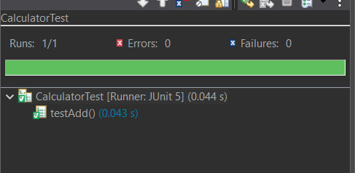

**3) Assertions in Junit**

package com.example;

import static org.junit.Assert.*;

import org.junit.Test;

public class AssertionsTest {

*@Test*

public void testAssertions() {

// Assert equals

*assertEquals*(5, 2 + 3);

// Assert true

*assertTrue*(5 > 3);

// Assert false

*assertFalse*(5 < 3);

// Assert null

*assertNull*(null);

// Assert not null

*assertNotNull*(new Object());

}

}

**Output:**

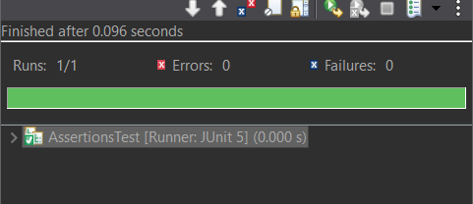

**4) Arrange-Act-Assert (AAA) Pattern, Test Fixtures, Setup and Teardown Methods in JUnit**

package com.example;

public class Calculator {

public int add(int a, int b) {

return a + b;

}

public int multiply(int a, int b) {

return a * b;

}

}

package com.example;

import org.junit.After;

import org.junit.Before;

import org.junit.Test;

import static org.junit.Assert.*;

public class CalculatorTest {

private Calculator calculator;

// Setup method: runs BEFORE each test

*@Before*

public void setUp() {

calculator = new Calculator();

System.***out***.println("Setup: Calculator instance created");

}

// Teardown method: runs AFTER each test

*@After*

public void tearDown() {

calculator = null;

System.***out***.println("Teardown: Calculator instance set to null");

}

*@Test*

public void testAdd() {

// Arrange

int a = 2;

int b = 3;

// Act

int result = calculator.add(a, b);

// Assert

*assertEquals*("2 + 3 should be 5", 5, result);

}

*@Test*

public void testMultiply() {

// Arrange

int a = 4;

int b = 5;

// Act

int result = calculator.multiply(a, b);

// Assert

*assertEquals*("4 * 5 should be 20", 20, result);

}

}

**Output:**

